Day 16
Task 3
- Load the csv files
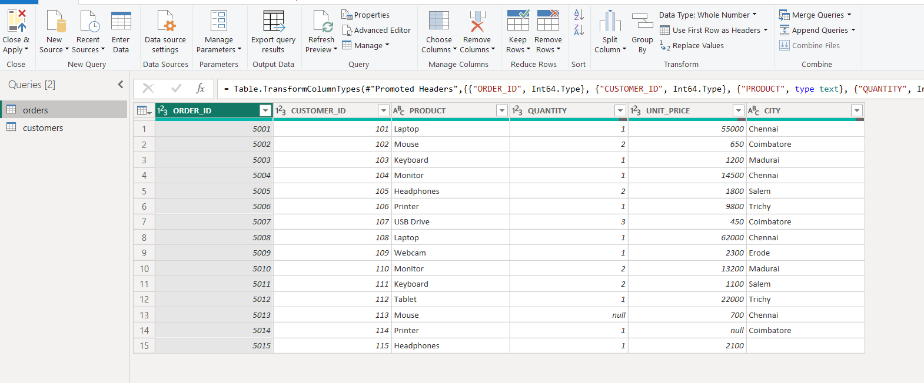
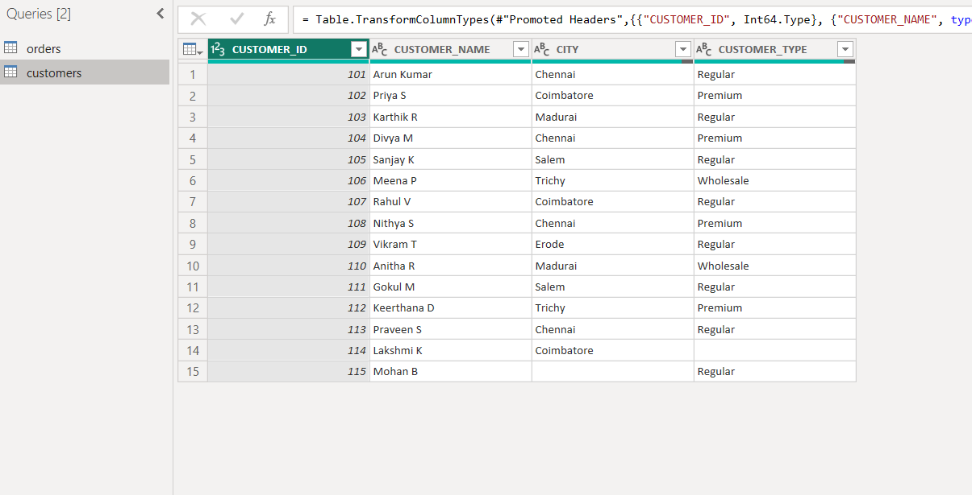

- Goto Transform and click format—>trim
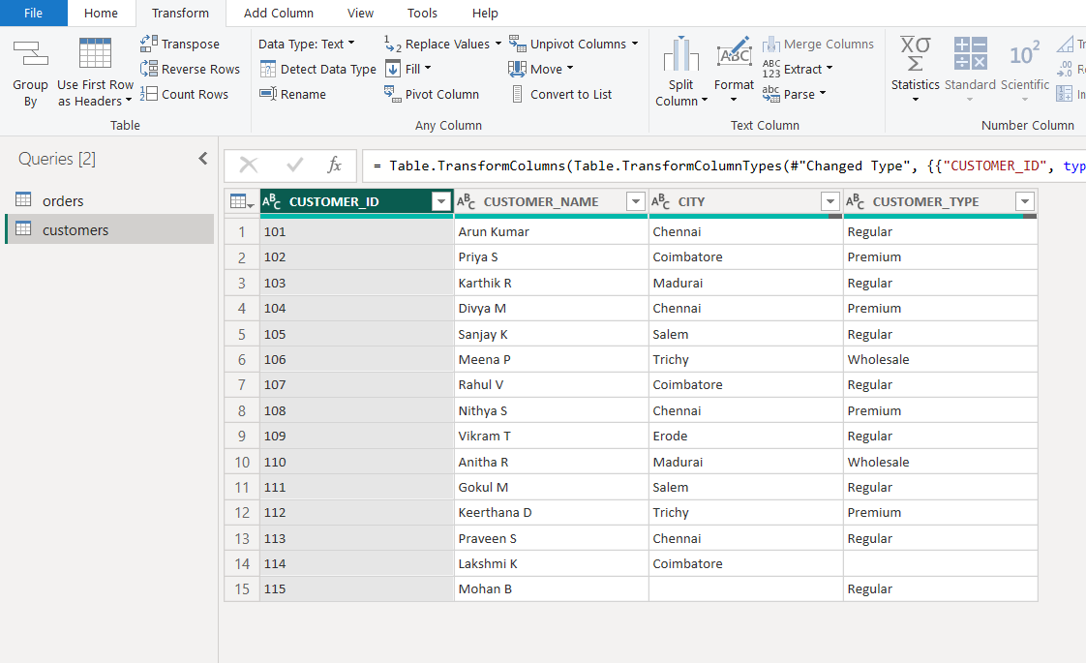

- Merge Queries
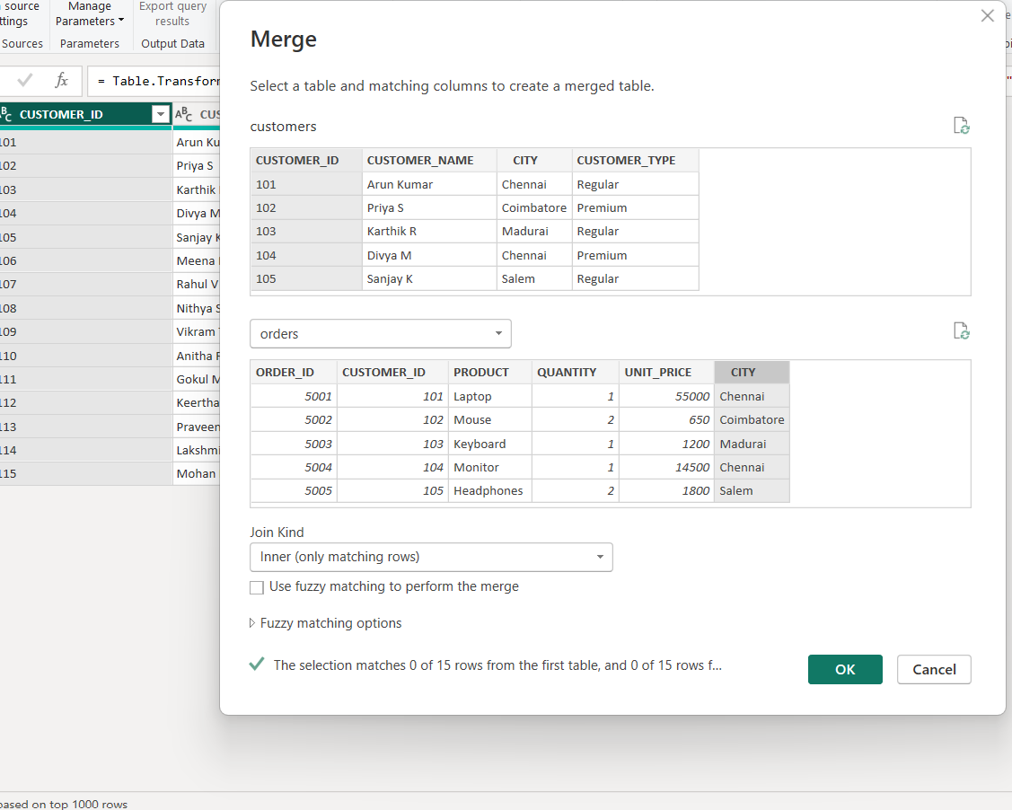

- Add a new column in ORDERS table called revenue
REVENUE= [QUANTITY] * [UNIT PRICE]
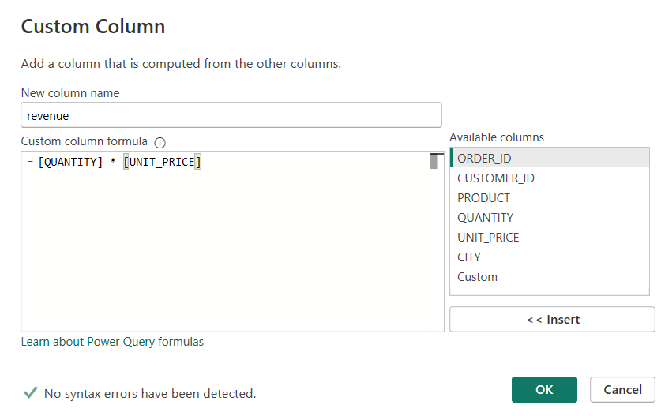
New column REVENUE added
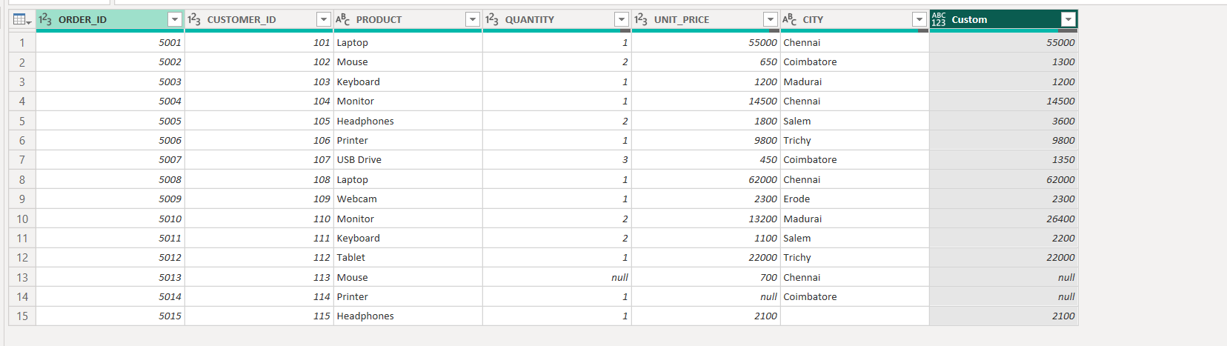

- Data Visualization in table format
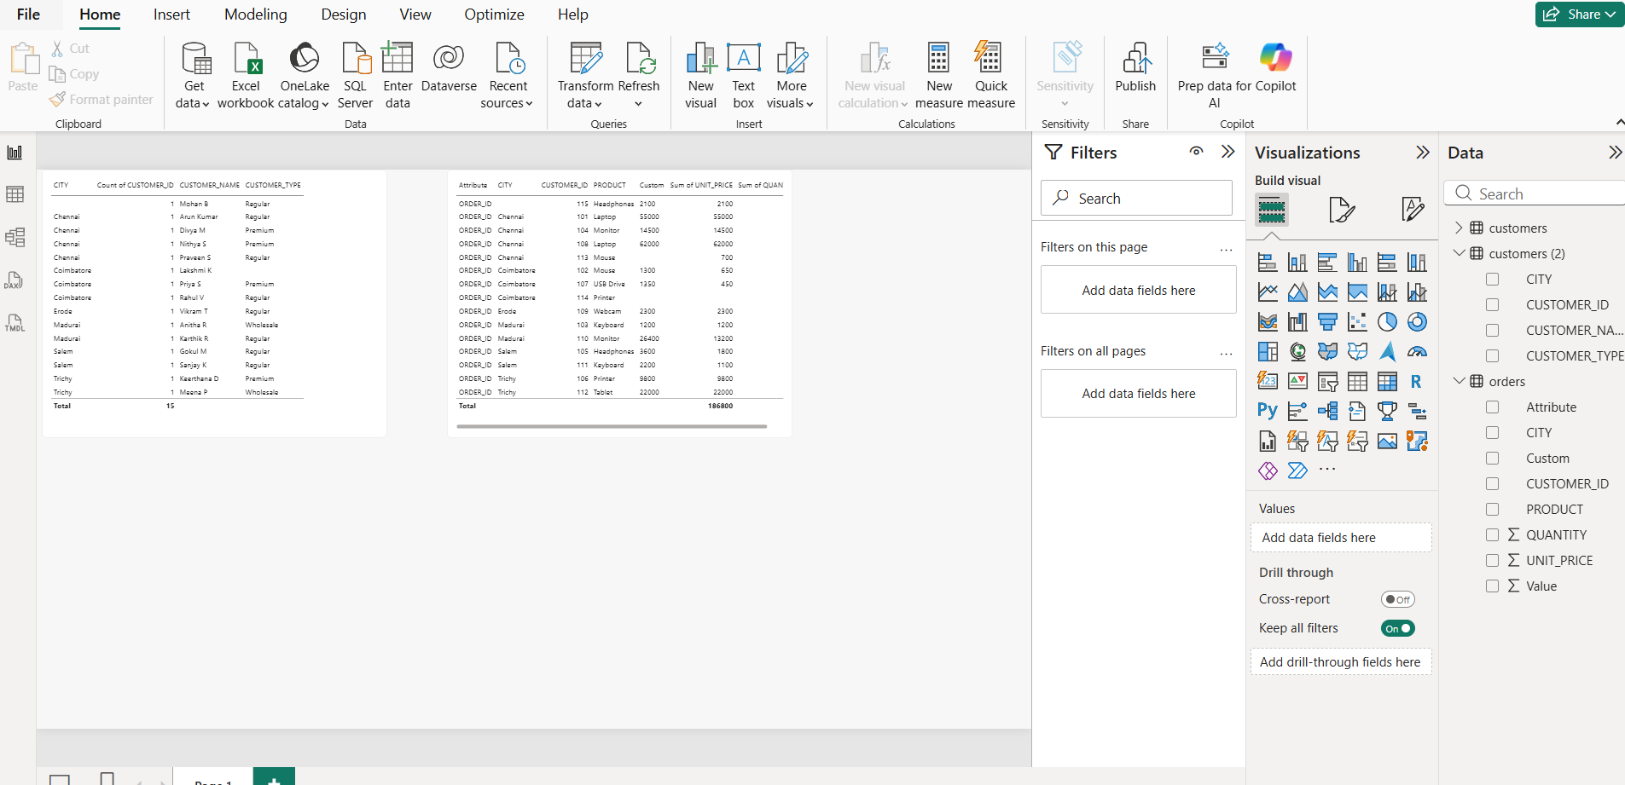

Customer table
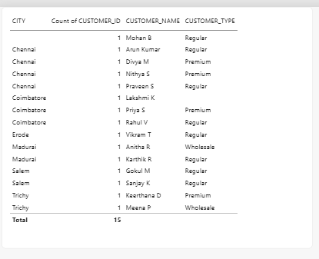

Orders Table


